Software quality

Fontys University of Applied Science Software

Project Plan Individual project:

Tutor: Tim Kurvers & Maja pesic

Student: Mohammed Al Harbi

4089553

Contents

Introduction: 3

Sonarqube: 3

Jacoco: 4

# Introduction:

In this document I would try to prove that I do care about the software quality with some screenshots to proof that.

# Sonarqube:

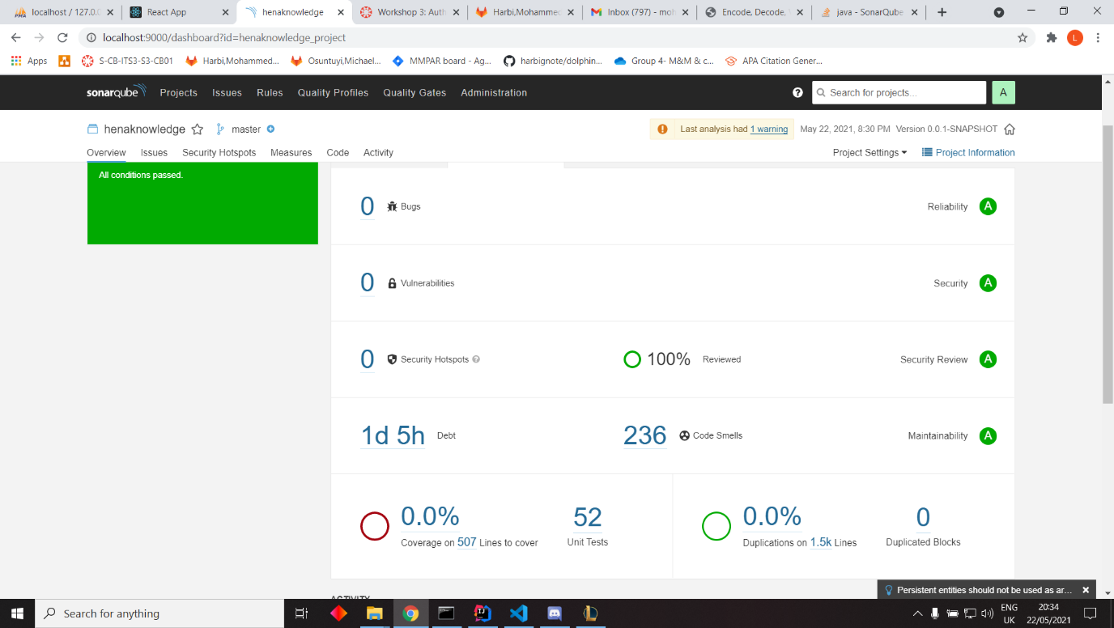

This is from sprint 3 version results shown in SonarQube. The coverage is broken, it does not state exactly the coverage percentage but SonarQube passed the program.

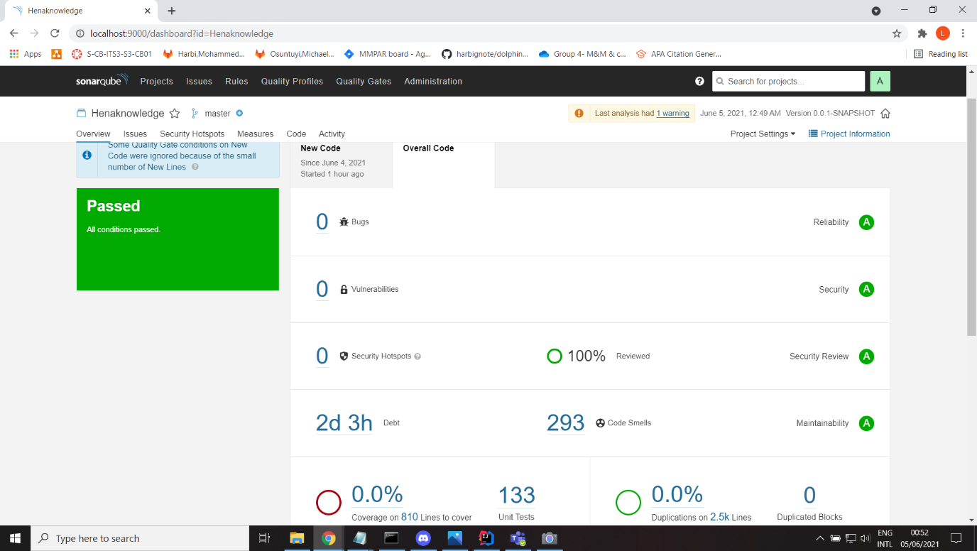

In picture above I have 133 unit tests. However, the issue from sprint 3 remained the same (shallow clone decided.) the coverage is not shown properly.

Jacoco: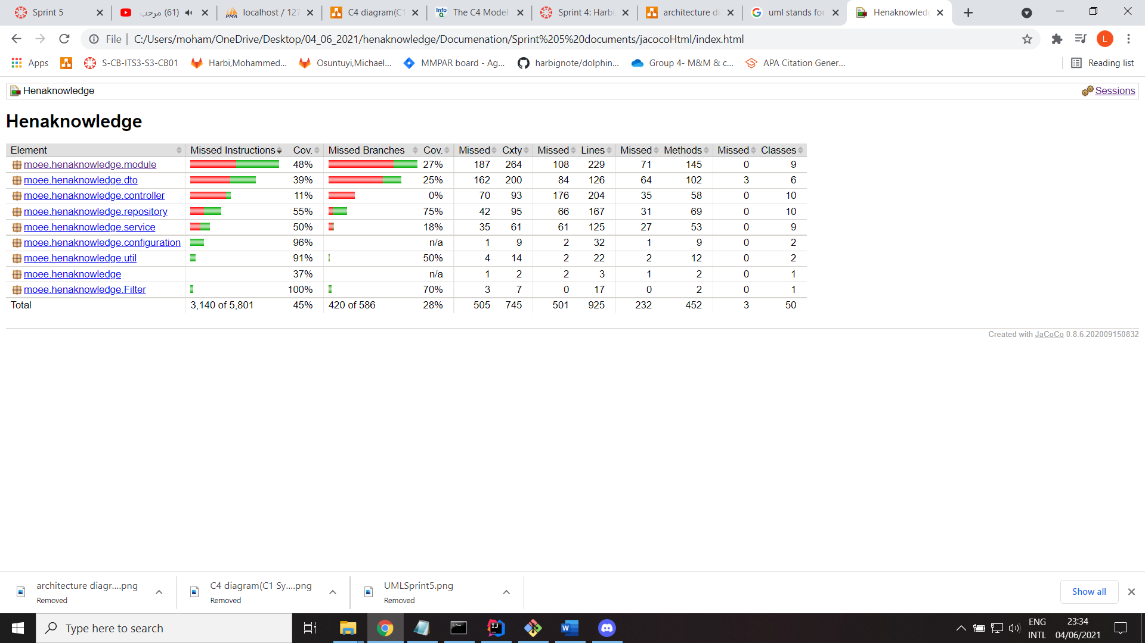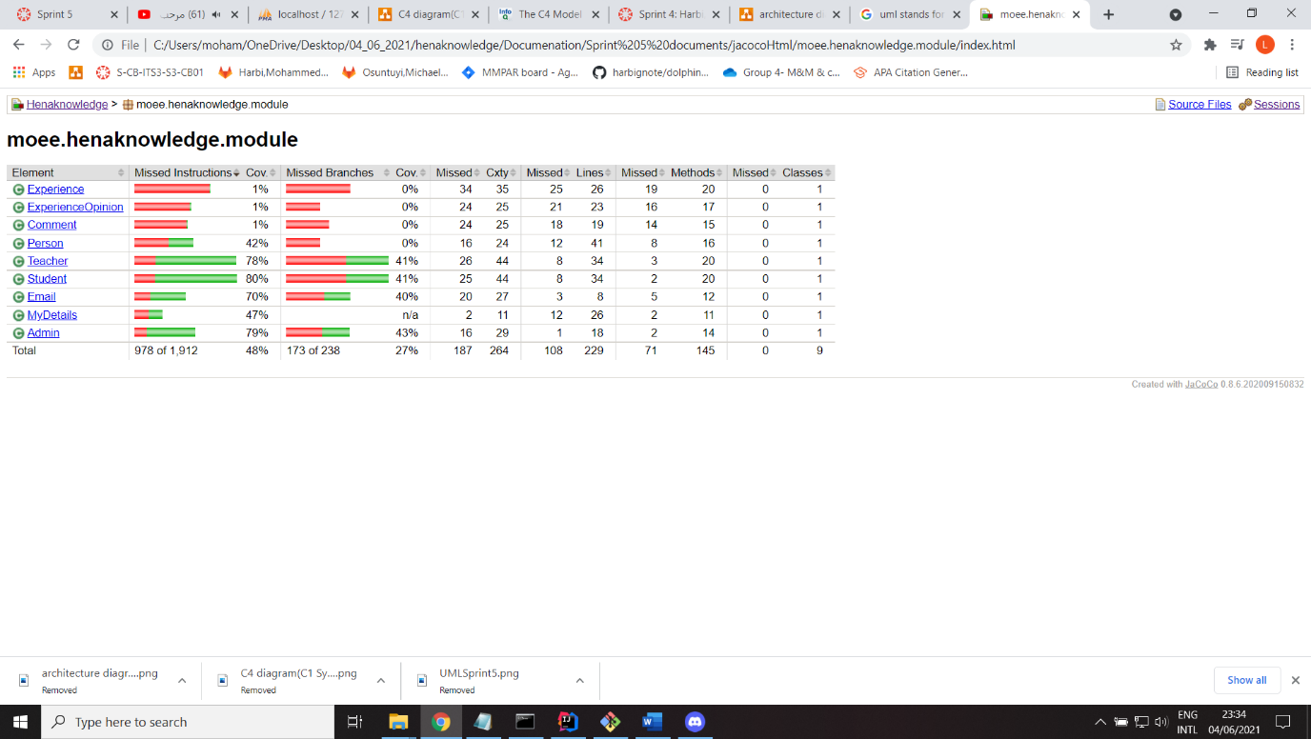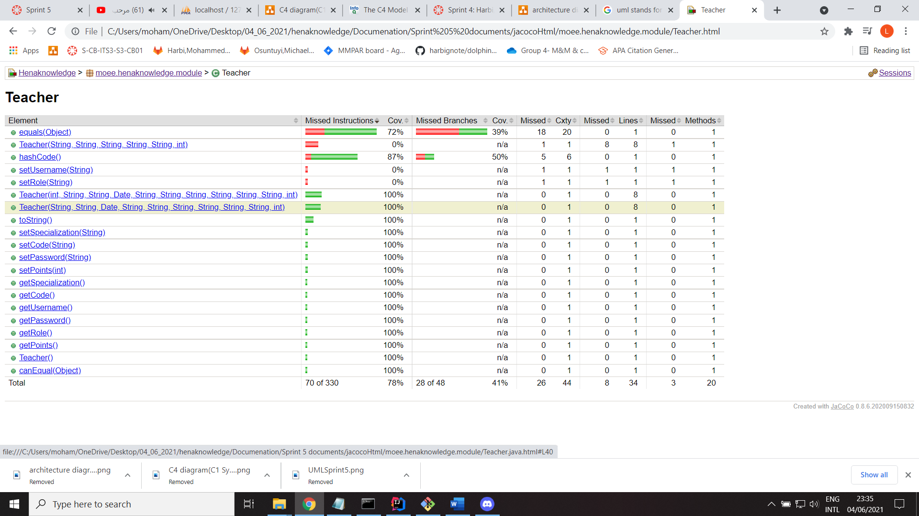

These are some samples of Jacoco results since the amount of unit tests and coverage are broken at the moment in SonarQube.

The full Jacoco report is also available in the document folder.